Title

First and last Name

Abstract
(no less than 200 and no more than 250 words)

Purpose:
Methodology:
Findings:
Implications for theory and practice:
Originality and value:

Keywords (5-10): keyword 1, keyword 2, keyword 3, keyword 4, keyword 5, keyword 6, keyword 7, keyword 8, keyword 9, keyword 10

Introduction (rationale for study, whether aim and research question(s), gaps are identified/ if pertinent literature is reviewed, research reviewed and critiqued, important terms defined, the aim of the manuscript and/or research presented).
Text ……………………………….

Literature review (demonstration of an adequate understanding of the relevant literature, up to date sources, significant work(s) ignored or not); the author's position towards other researchers and research).
Text ………………………………..

Methodology/Research methods (comment whether a sample is correct, data-gathering methods or procedures are described, the procedures and analytic technique(s) described).
Text ………………………………..

Results (comment whether the results are made properly, compared and contrasted with relevant literature conclusions drawn logically, tables and figures elaborated and discussed correctly. Tone of the article displays an unbiased, impartial scientific attitude).
Text ………………………………..

Discussion (comment on the results, reference to the main goal of the manuscript, the hypothesis/research problem; summary/overview of the most important discoveries; it should be shown whether they support or allow to reject the hypothesis, whether they answer research questions, how they translate into the achievement of goals; are they similar or different from the discoveries of other researchers; explanation of discoveries and speculations about them, supported by references to literature.

Conclusion(s) (comment whether conclusions are related to the aim and research questions, hypotheses, implications for research and practice and directions for further research are introduced, limitation of the analysis is presented).
Text ………………………………..

Acknowledgment(s)
Text……………………………….

References (APA Style 6th)
Text………………………………

Biographical note (s)
Text…………………………

Conflicts of interest (Publisher note)
Text…………………………

Suggested citation (Publisher note)
Text…………………………

Insert all Tables and Figures in the body of the manuscript

Table 1. Title
Column1 | Column2
Row1 | Row1
Row2 | Row2
Row3 | Row3
Row4 | Row4
Row5 | Row5
Source: Author (2013, p. 34).

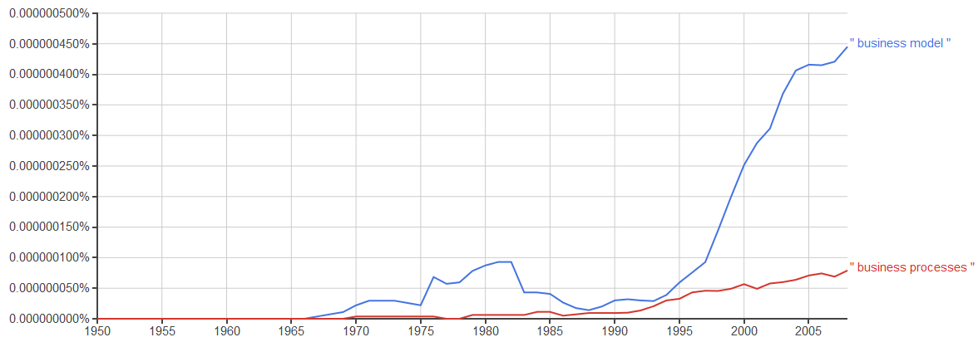
Figure 1. Business model and business processes trends
Source: based on Google Ngram Viewer.

Editorial notes

The article should be provided in electronic form (Microsoft Word). Standard A4 page with standard margins (2.5cm). The text should be written in Times New Roman font - 12 points, spacing between lines 1.0. The title of the article is in bold 14 points. Footnotes directly in the text, e.g. (Name, 2022 or Name & Name, 2023). We designate the tables at the beginning - we give the source under the table, while the captions and the source under the figures. The manuscript should be 15-20 pages (6000 - 8000 words). Abstract with the title at the beginning of the article. In the end, biographical note (s). The use of a PAPER TEMPLATE is obligatory.

First and last name, Title, Position, Department, University or Institution, Street with no., Town with code, Country, e-mail: name@surname.edu (ORCID: 000000000000).

